WEB-BASED REAL-TIME EMOTION DETECTION



A project presented to the National University in partial fulfillment of the requirement for the degree of Master of Science & Engineering.

Submitted By; MdAzad
Exam Roll:2310047
Reg. No:22602019081

Department of Computer Science and Engineering
of Institute of Science and Technology(IST)
Under National University, Bangladesh.

DECLARATION

I certify that the project has not already been submitted for any degree and is not being submitted as part of candidature for any other degree. I also certify that the project has been written by me and I received in preparing this project and all sources used, have been acknowledged in this project.

………………………………..
Md.Azad

APPROVAL

This is to certify that the entitled “Real-Time Emotion Detection” submitted to Institute of Science and Technology(IST) University of Bangladesh for the degree of Master of Science by Md.Azad, is an analytical work done by her under my supervision. To the best of my knowledge, the project has not previously formed the basis for the award to the candidate of any degree, diploma, fellowship, or any other similar title and the work has not been submitted to any university or institution, for award of any other degree. The project presents the independent original contribution of the candidate

Date: ………………………………
(Supervisor)
Tasmi Sultana
Asst. Professor, Department of CSE
Institute of Science and Technology(IST)

ACKNOWLEDGEMENT

I would like to express my deep gratitude towards the Almighty and my sincere appreciation to my project supervisor Tasmi Sultana for her able guidance and supervision which helped me to start this project. I am extremely grateful and remain indebted to them for being a source of inspiration and for their constant support in the idea and start of the project.

I would also like to thank my Head of Department Lutfi Habiba and all other faculty members of the Computer Science and Engineering Department, have rendered me significant encouragement, in various support and continuous & kind guidance. I thank them all for their invaluable guidance and other people who directly or indirectly assisted us in the successful and timely completion of the “REAL-TIME EMOTION DETECTION”.

ABSTRACT

The " Real-Time Emotion Detection" project focuses on developing an advanced system that utilizes machine learning and computer vision techniques to detect and classify human emotions based on facial expressions from both live video streams (via webcam) and image uploads. The system operates without the need for a database, making it lightweight and privacy-conscious by processing and analyzing data in real time without storage.

The backend, built using Python, incorporates OpenCV for facial detection and a pre-trained Keras model for emotion classification. The system supports two modes of input: live video streaming through a webcam and static image uploads. Once the facial features are detected, the system categorizes emotions such as happiness, sadness, anger, and surprise, delivering immediate feedback to the user. The frontend, developed with React, offers a user-friendly interface, allowing seamless switching between webcam-based detection and image uploads, with real-time emotion results displayed on the screen.

This project can be applied in industries like customer service, mental health, and security to gain insights into emotional responses, track well-being, and detect stress or suspicious behavior. Future enhancements could include extending the system to support criminal detection and fraud prevention through advanced facial recognition technologies.

TABLE OF CONTENTS

SL No. Chapter Name Page No.

Chapter 1: INTRODUCTION 01
  - Introduction 02
  - Motivation 02
  - Scope of the work 02
  - Objective 02
  - Organization of the project. 03
Chapter 2: LITERATURE REVIEW 05
  - Introduction 06
  - Background Analysis 06
  - Real-Time Emotion Detection System 06
  - Real-Time Emotion Detection Concept 07
  - Conventional vs. Real-Time Emotion Detection Systems 07
  - Summary 08
Chapter 3: EXISTING SYSTEM OVERVIEW 09
  - Introduction 10
  - Existing System 10
  - Limits of Existing System 11
  - Performance Factor 11
  - Summary 12
Chapter 4: PROPOSED SYSTEM DESIGN 13
  - Introduction 14
  - Overview 14
  - Features of Proposed System 14
  - Emotion Detection Algorithm 15
  - System Requirements 16
  - Use Case Diagram 16
SL No. Chapter Name Page No.
Chapter 5: IMPLEMENTATION 18
  - The Problem in Hand 19
  - Requirements 19
  - Implementation 20
Chapter 6: TESTING 22
  - Why Testing is Needed 23
  - Testing Strategy 23
Chapter 7: CONCLUSION AND FUTURE WORK 26
  - Conclusion 27
  - Future Work 27

Chapter 1 INTRODUCTION

Introduction
Information systems have revolutionized various aspects of daily life, increasing efficiency and reducing the time required for numerous tasks. Among these advancements is the Face Emotion Detection System, which utilizes Machine Learning Technology to analyze facial expressions and interpret human emotions in real time. This system offers an objective, consistent, and automated method to understand emotional states by capturing live images or videos, processing facial cues, and categorizing emotions like happiness, sadness, anger, surprise, and more.

Manual observation remains the most common way to detect emotions, but it is often subjective, slow, and prone to error. The Face Emotion Detection System overcomes these limitations by providing a reliable, scalable, and fast solution capable of processing large amounts of data in real time, thus reducing errors and ensuring consistency in emotion interpretation.

Motivation
Understanding human emotions has become increasingly important in fields like customer service, mental health, and security. Emotions significantly influence decision-making, communication, and behavior. However, manually assessing emotions is often inaccurate, time-consuming, and subjective.

Automating this process through the Face Emotion Detection System enables organizations to better gauge customer satisfaction, monitor emotional well-being, and improve security by identifying emotional cues such as stress or anxiety. For example, in customer service, detecting emotions can help tailor interactions for a more satisfying experience. In mental health, tracking emotional changes can provide insights into a patient’s mental state, while in security, identifying emotions like nervousness can help prevent dangerous situations.

Emotional data also holds immense value in industries like marketing, education, and entertainment, where understanding users’ emotional responses can enhance product development, content creation, and personalized learning experiences.

Scope of the Work
This project aims to develop a Real-Time Face Detection System that captures and analyzes facial expressions using machine learning algorithms. The system will detect emotions such as happiness, sadness, anger, and surprise in real time, offering immediate feedback.

The system can be applied in various industries:

    - Customer Service: Monitor customer emotions to enhance service quality.
    - Mental Health: Track emotional states to assist in mental health interventions.
    - Security: Detect stress or suspicious behaviors for threat prevention.
    - Marketing: Gain insights into customer reactions to products or services.

In the future, the system could be expanded to include criminal and fraud detection, leveraging facial recognition technologies to assist law enforcement and prevent fraud.

Objectives

The Face Emotion Detection System is designed to automate the process of detecting and interpreting emotions in real time. The primary objectives of the system include:

    - Accurately detecting a variety of human emotions based on facial expressions.
    - Displaying real-time emotion results through a user-friendly interface.
    - Storing user interactions, detected emotions, and feedback for further analysis.
    - Helping users or organizations enhance their services by understanding emotional responses.
    - Providing a flexible and scalable platform that can be used in various fields such as customer service, mental health, security, education, and marketing.
    - Enabling easy integration with different devices, allowing users to interact with the system from anywhere.

Organization of the Project

This project is organized into the following chapters:

Introduction

This chapter introduces the project by providing a general overview, explaining the motivation behind the work, outlining the scope, and stating the primary objectives. It also briefly explains how the project is organized

The second chapter is dedicated to a literature review.This chapter analyzes existing research and background information relevant to the project, covering related systems and their benefits. It establishes the foundation for understanding the concepts used in the project.

The third chapter outlines the existing systems currently available. It examines their limitations and performance factors, highlighting the need for improvements and why the proposed system is necessary.

The fourth chapter presents the system design. It details the features, requirements, and structure of the proposed system. Diagrams like the Use Case and Data Flow Diagrams help illustrate how the system will function.

The fifth chapter covers the implementation. This chapter delves into the practical aspects of building the system. It explains the technologies used and gives a step-by-step breakdown of each module, supported by screenshots and code examples.

The sixth chapter focuses on testing. It describes the testing strategies employed to ensure the system functions correctly. The chapter also presents test cases and results, showing the reliability and accuracy of the system.

The final chapter concludes the project, summarizing the key findings and contributions. It also explores potential future work, such as the integration of criminal and fraud detection features.

Chapter 2 LITERATURE REVIEW

Introduction

The purpose of this chapter is to explore the existing body of knowledge related to real-time emotion detection systems. This review will cover the fundamental concepts of emotion detection technology, its evolution with the rise of artificial intelligence, and the benefits of adopting such a system for real-time analysis. By understanding advancements in face detection technology, we can design a more effective and efficient system that addresses real-time emotion analysis and other potential applications, such as criminal and fraud detection.

Background Analysis

The evolution of face detection systems has been driven by advancements in computer vision and machine learning. Historically, face detection was a manual process, requiring human oversight to identify faces in images or videos. As the demand for automation increased, early algorithms for automatic face detection emerged, marking the beginning of computer-based facial recognition systems.

With the rise of deep learning and artificial intelligence, face detection technology has seen dramatic improvements. Modern systems are now capable of detecting faces in real time, extracting detailed facial features, and even recognizing emotions and behavioral patterns. These innovations have led to the widespread adoption of face detection technology in industries such as security, healthcare, and customer service, where real-time analysis can streamline operations and enhance outcomes.

Real-Time Emotion Detection System

A Real-Time Emotion Detection System is designed to automatically capture and analyze facial features from live video or image streams. The system processes video feeds in real time, detecting faces and interpreting emotional states. Key functions include:

    - Face Detection: Identifies and isolates human faces within live video streams.
    - Emotion Recognition: Classifies facial expressions into categories such as happiness, sadness, anger, and surprise.
    - Immediate Feedback: Displays real-time results to users, allowing quick responses to detected emotions.

By offering real-time processing, these systems are ideal for applications that require immediate emotional feedback, such as customer interaction analysis, mental health assessments, or security monitoring.

Real-Time Emotion Detection Concept

The concept behind Real-Time Emotion Detection revolves around automating the detection and analysis of faces and emotions with minimal human intervention. Using advanced machine learning and computer vision techniques, the system can process each frame of a video stream, identify faces, and interpret emotions by analyzing facial expressions.

Key technologies involved in real-time face detection include:

    - Computer Vision Algorithms: To detect and track faces in real-time video streams.
    - Machine Learning Models: To classify emotions based on facial features.
    - Real-Time Data Processing: Processes live data to provide immediate results, without storing facial data.
    - User Interface: A display that presents detected emotions in real time, ensuring users can act on the insights immediately.

The system is designed to be highly interactive and capable of supporting multiple applications, from improving customer service to detecting behavioral cues in security.

Adopting a real-time emotion detection system offers several advantages, including:

    - Real-Time Emotional Insights: Immediate detection of emotional states enables quick, actionable responses.
    - Increased Efficiency: Automation reduces the time and resources required for manual observation and analysis.
    - Scalability: The system can handle multiple facial inputs simultaneously, making it suitable for large-scale use.
    - Enhanced User Interaction: Real-time feedback enriches user experiences across industries such as customer service, healthcare, and security.

By providing instant feedback, the system enhances operational efficiency while improving the quality of user interactions in various domains.

Conventional vs. Real-Time Emotion Detection Systems

Traditional Emotion detection systems relied heavily on human observation and were both time-consuming and resource-intensive. In contrast, Real-Time Emotion Detection Systems automate the process using advanced AI and machine learning algorithms. This automation enables faster, more accurate detection of faces and emotions, providing real-time analysis that can scale to handle large amounts of data without significant manual involvement.

Where conventional systems were limited in their capacity to process data, real-time systems offer:

    - Automation: Replacing manual observation with AI-powered recognition.
    - Speed and Efficiency: Real-time processing with minimal human effort.
    - Scalability: Handling multiple inputs and delivering insights instantly.

Real-time systems also provide more accurate, actionable insights into emotional and behavioral patterns, making them more effective for modern applications.

Summary

This chapter reviewed the evolution of face detection technology, with a focus on the shift from manual methods to automated, real-time systems. We discussed the core features of a real-time face detection system, the technologies powering it, and the benefits it offers. This overview highlights the system's potential for widespread use in industries like security, healthcare, and customer service, with future opportunities to expand into criminal and fraud detection.

Chapter 3
EXISTING SYSTEM OVERVIEW

Introduction

The advancements in face detection technology have led to the development of various systems that aim to automate facial recognition and emotion analysis. In this chapter, we explore the existing systems available in the market and evaluate their limitations and performance. These systems serve as the foundation upon which improvements and innovations for real-time face and emotion detection can be built, especially when considering future use cases such as criminal and fraud detection.

Existing System

Currently, several face detection and emotion recognition systems are available in the market, each with varying degrees of functionality and accuracy. Some of the prominent categories include:

    - Basic Face Detection Systems: These systems can detect faces in images or videos but lack emotion analysis capabilities. They primarily serve security and authentication purposes, such as access control systems that use face detection to unlock devices or doors.

    - Emotion Recognition Systems: These systems, built on machine learning algorithms, are designed to analyze facial expressions and identify emotions like happiness, sadness, surprise, and anger. Examples include Affectiva, Noldus FaceReader, and Microsoft's Azure Emotion API. These solutions are used in customer service, marketing, and mental health monitoring to gauge user emotions and tailor experiences accordingly.

    - Real-time Surveillance Systems: Real-time face detection is integrated into surveillance systems used in high-security areas like airports, shopping malls, and public events. These systems are focused more on identifying known individuals or suspicious behaviors and, in some cases, can analyze stress levels or nervousness to alert authorities.

Limits of Existing System

Despite the progress, current systems still face several limitations:

    - Limited Emotion Categories: Many existing systems focus on detecting a limited range of emotions, often restricted to basic ones like happiness, sadness, or anger. This can reduce the effectiveness of the systems in applications where a more nuanced understanding of emotions is required.

    - Accuracy Issues: The accuracy of emotion detection can vary greatly depending on factors such as lighting, facial angle, and image quality. In many cases, existing systems struggle with real-time accuracy, especially when processing large amounts of data simultaneously.

    - Lack of Real-time Processing: Some systems still operate in a non-real-time manner, processing images or videos in batches rather than offering instantaneous feedback. This delay reduces their applicability in scenarios that demand immediate action, such as security monitoring.

    - High Computational Requirements: Many emotion detection systems require substantial computational power, especially when using deep learning algorithms, making them less accessible for smaller organizations or devices with limited resources.

    - Subjectivity in Emotion Interpretation: Even though systems use machine learning, emotion interpretation can still be subjective due to cultural differences or individual expressions. This results in occasional false positives or incorrect classification of emotions.

Performance Factor

The performance of existing systems is influenced by multiple factors:

    - Accuracy: The precision of face detection and emotion analysis in various lighting and environmental conditions is a crucial measure of system performance. While some systems perform well in controlled environments, they often struggle in dynamic, real-world conditions.

    - Speed: Real-time processing speed is essential for applications like surveillance or customer service. Systems with higher latency may fail to provide timely insights, reducing their practical utility in time-sensitive situations.

    - Scalability: Most systems face challenges when scaling to handle large amounts of data, especially in real-time. Those integrated into large-scale surveillance systems must be able to process multiple video streams without compromising accuracy or speed.

    - Integration: The ease with which these systems can be integrated into existing infrastructures also affects performance. Systems that are compatible with various devices and platforms tend to be more successful in adoption across industries like security, customer service, and healthcare.

Summary

In summary, while existing face detection and emotion recognition systems have paved the way for automated emotion analysis, they still have limitations in terms of accuracy, real-time performance, and scalability. These limitations highlight the need for more advanced systems that can overcome these barriers, particularly in high-stakes environments like security and mental health. In the upcoming chapters, we will address these gaps and propose a more robust system that integrates criminal detection and fraud detection capabilities for a wider range of applications.

Chapter 4
PROPOSED SYSTEM DESIGN

Introduction

The proposed system aims to detect human emotions in real time using facial expressions captured from live video or uploaded images. This system uses modern web technologies and machine learning techniques to process and analyze the data without storing any information in a database. The frontend facilitates user interaction, while the backend handles image processing and emotion recognition. This chapter outlines the key features, technical requirements, system architecture, and data flow structure of the Real-Time Face Detection and Emotion Recognition System.

Overview

The Real-Time Face Detection and Emotion Recognition System is designed to capture and analyze live video feeds or uploaded images to detect and classify emotions from human faces. The frontend is built with React.js to provide an interactive user interface, while the backend utilizes FastAPI and Python libraries like OpenCV and TensorFlow/Keras to detect faces and analyze emotions in real time. The system communicates through WebSocket for real-time updates and immediate feedback to the user.

Features of Proposed System

The system has the following key features:

Real-Time Emotion Detection:

The system's core functionality revolves around real-time emotion detection. By using OpenCV’s Haar Cascade Classifier, the system can accurately locate faces in a video feed or image. The classifier identifies key facial features such as eyes, nose, and mouth, which helps pinpoint a person’s face in different lighting conditions and angles. This process occurs in real time, allowing users to instantly detect their face as soon as the webcam starts or the image is uploaded. The system ensures quick response times to create a seamless experience

Frontend with React:

The frontend is built using React.js, a popular JavaScript library for building interactive user interfaces. React’s component-based architecture allows for modular, reusable UI elements that make the application easy to scale and maintain. It supports dynamic updates to the UI without the need to refresh the page, ensuring a smooth user experience. In this system, React handles tasks such as displaying the live video feed, showing image uploads, and rendering the detected emotions in real time. Tailwind CSS is used to ensure a modern, responsive layout that adapts to various screen sizes.

Backend with FastAPI and TensorFlow:

The backend is powered by FastAPI, a high-performance web framework known for its speed and asynchronous capabilities. FastAPI manages the communication between the frontend and backend, handling API requests efficiently. Emotion detection is handled by a TensorFlow/Keras-based model, which has been pre-trained to recognize a range of emotions such as happiness, sadness, anger, and surprise. This model processes images in real time to output the predicted emotion. By utilizing TensorFlow, the system can leverage deep learning to provide accurate emotion predictions from facial expressions.

WebSocket Communication:
To ensure real-time feedback between the frontend and backend, the system employs WebSocket communication. Unlike traditional HTTP requests, WebSockets allow for continuous, bi-directional communication between the client and the server. This ensures that as soon as the backend detects emotions, the information is pushed to the frontend without any delay. This technology is particularly useful for real-time applications like this one, as it minimizes lag and allows users to receive immediate feedback on their facial emotions while interacting with the system

Emotion Display:

Once the backend has detected the user’s emotions, the results are displayed on the frontend. This happens in real time, ensuring that the user sees immediate updates as they change their facial expressions. The emotions are shown in a user-friendly manner, typically with text labels such as “happy,” “sad,” or “angry.” Additionally, graphical elements such as icons or emoji-like visuals can be used to make the system more intuitive and engaging. This immediate feedback helps users understand their emotional state based on facial expressions captured by the system.

Emotion Detection Algorithm

In the backend, the face detection is handled by OpenCV, while emotion recognition is managed by a pre-trained TensorFlow/Keras model. The detected emotion is then sent back to the frontend using WebSocket for real-time display.

System Requirements

Frontend:

- React.js: The web interface is built using React for a dynamic and responsive user experience.
- Tailwind CSS: For a clean and responsive user interface.
- WebSocket: For real-time interaction between the client and server.
- Image Upload and Live Camera Feed: Users can upload images or provide input through a webcam.

Backend:

- Python 3.8: Backend logic is written in Python 3.8.
- OpenCV: Used for face detection,utilizing the Haar Cascade Classifier (haarcascade_frontalface_default.xml).
- TensorFlow/Keras: For emotion detection using a pre-trained neural network model (model.h5).
- Uvicorn: For running the FastAPI application, enabling asynchronous communication with the frontend.
- WebSocket (websockets, starlette): To provide real-time updates between the client and server.
- FER (Facial Expression Recognition): For detecting facial emotions from the captured or uploaded images.

Since this project does not use a database, all operations are conducted in memory without storing data.

Use Case Diagram

The primary actors involved in the system are the User and the System:

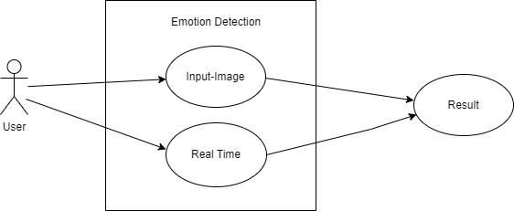

Figure 4.1: Use Case Diagram of Emotion Detection

User:

- Upload image or start live video feed for face detection and emotion analysis.
- View real-time feedback on detected emotions.

System:

- Capture face from input (webcam or uploaded image).
- Detect emotions from the captured face.
- Send emotion data back to the frontend for display.

Chapter 5 IMPLEMENTATION

The Problem in Hand

The current existing system for facial recognition and emotion detection often lacks real-time capabilities and may require significant computational resources to analyze data. Additionally, these systems may use a database for storing information, which can introduce privacy concerns and increase operational complexity. The aim of this project is to solve these issues by creating a Real-Time Face Detection and Emotion Recognition System that processes live video streams or image uploads without relying on a database. This new system focuses on real-time processing, improving accuracy, speed, and privacy.

Requirements
    - Hardware Requirements

To run this real-time face detection and emotion recognition system, the minimum hardware requirements include:

      - Processor:any
      - RAM: 2GB or higher
      - Storage: 1GB free disk space
      - Webcam: Built-in or external webcam for live face detection

Software Requirements

The system requires the following software and tools for successful implementation:

      - Operating System: Windows 7 / Linux (Ubuntu) / macOS
      - Programming Language: Python 3.8 (for backend logic and image processing)
      - React.js (for the frontend interface, handling live video feed and displaying emotion results)

Libraries/Dependencies:
      - OpenCV (for face detection using the Haar Cascade classifier)
      - TensorFlow/Keras (for emotion recognition using a pre-trained neural network)
      - WebSocket (for real-time communication between the frontend and backend)
      - Uvicorn (for running the FastAPI application)
      - FER (Facial Expression Recognition) (for detecting emotions based on facial features)
      - Code Editor: Visual Studio Code / PyCharm (for development)
      - Package Manager: pip (for managing Python dependencies)
      - Browser: Google Chrome/Firefox (for testing the frontend)

Implementation

The implementation process for the Real-Time Face Detection and Emotion Recognition System involves setting up both the frontend and backend components. Screenshots and code snippets will illustrate each section of the project.

Home Page

The Home Page is the main entry point to the Emotion Detection system. It provides a simple and interactive interface to navigate to other parts of the application such as face detection and image input for emotion analysis.
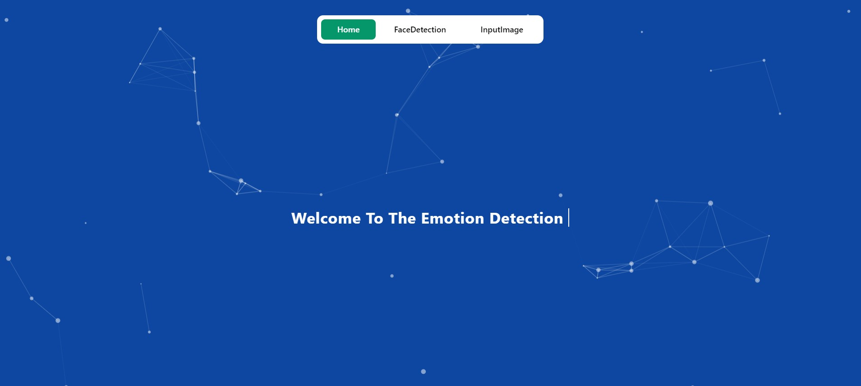

Figure 5.31: Home page

Live Face Detection

The live face detection feature allows the user to stream real-time video from their webcam. The system captures frames, detects the face using OpenCV, and sends the frames to the backend for emotion recognition.

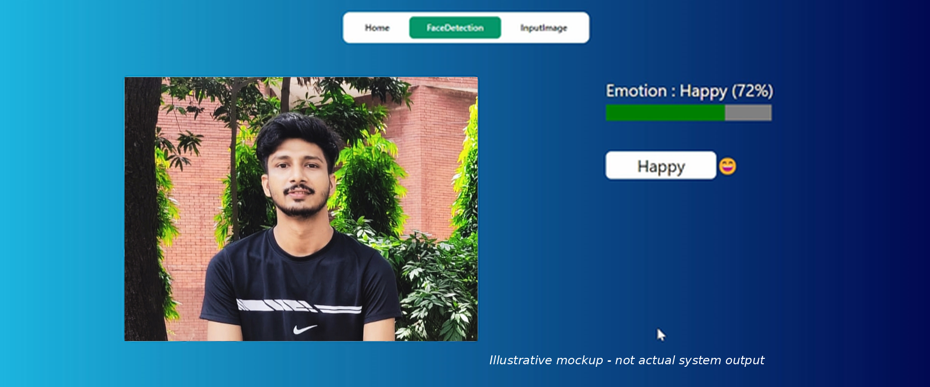

Figure 5.3.2 : Live Face Detection

Image Upload for Emotion Detection

The image upload page allows the user to upload an image file for facial emotion analysis. Once the image is uploaded, it is sent to the backend via FastAPI, where the face is detected, and emotions are analyzed.
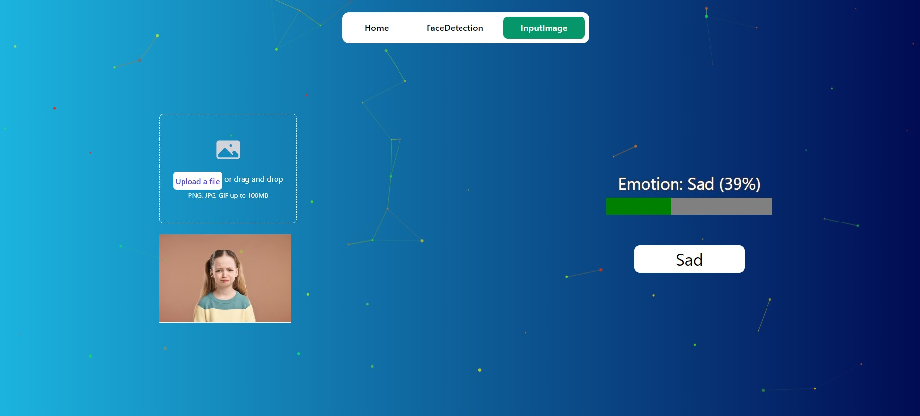

Figure 5.3.3 : Image Upload

Chapter 6

TESTING

Why Testing is Needed

Testing is a critical phase in the development of any software system, and the Emotion Detection System is no exception. The primary objective of testing is to ensure that the system operates as intended, without bugs or issues, and meets the requirements and expectations of its users. Testing also ensures that the system is reliable, accurate, and performs real-time emotion detection effectively.

Testing is needed in this project for the following reasons:

    - Quality Assurance: To ensure that all features, including face detection, emotion recognition, and user interactions, work flawlessly.
    - Bug Identification: To uncover and fix any unexpected behavior, crashes, or glitches in the system.
    - System Stability: To verify that the system performs consistently under different conditions, such as varying network speeds or device types.
    - Usability: To confirm that the user interface is intuitive and user-friendly, offering a smooth experience when interacting with the system.
    - Performance Testing: To assess the system's ability to handle real-time data and provide accurate emotion feedback in a timely manner.

Testing Strategy

To ensure the system's reliability, accuracy, and performance, a combination of the following testing techniques will be employed:

    - Unit Testing: This type of testing focuses on individual components (such as the face detection algorithm, emotion recognition, and navigation features) to ensure that they work as expected in isolation.
    - Integration Testing: This will verify that different parts of the system (frontend, backend, and WebSocket communication) work well together.
    - End-to-End Testing: This involves testing the entire system from start to finish, simulating real user behavior and validating that the system performs as expected.
    - Usability Testing: This will ensure that users can easily navigate the interface, upload images, and receive emotion feedback in real time.
    - Performance Testing: The system will be tested for real-time performance, especially for face detection and emotion recognition accuracy.
    - Error Handling Testing: The system will be tested for unexpected inputs, such as blurred images, poor lighting, or no face detection, to ensure proper error handling and feedback to the user.

Test Case Study

A test case is a set of conditions or variables under which a tester determines whether the system is functioning correctly. Below is an example of a test case study that will be used to validate the Emotion Detection System.

Test Case 1: Uploading an Image for Emotion Detection

      - Objective: Verify that the system can correctly process an uploaded image and return emotion recognition results.

Preconditions:
        - The user is on the "Input Image" page of the application.
        - The user has an image file ready for upload (e.g., a portrait photo with a clear face).

Steps:
        - Navigate to the "Input Image" page.
        - Click the "Upload Image" button.
        - Select an image file from the device and upload it.
        - Wait for the image to be processed by the backend.
        - Review the emotion detection results displayed on the screen.

Expected Result:
        - The image is successfully uploaded.
        - The system detects the face(s) in the image.
        - The system correctly identifies the emotion (e.g., happy, sad, angry, etc.) and displays it on the screen.

Test Case 2: Real-Time Face Detection and Emotion Recognition

      - Objective: Verify that the system can detect and recognize emotions from a live webcam feed.

Preconditions:
        - The user is on the "Face Detection" page.
        - The user’s webcam is functioning properly.

Steps:
        - Navigate to the "Face Detection" page.
        - Start the live video feed using the webcam.
        - Wait for the system to detect the face in real-time.
        - Observe the emotion feedback displayed on the screen as the user makes different facial expressions.

Expected Result:
        - The system detects the user’s face in real-time.
        - The system recognizes and displays the emotion accurately (e.g., happy, sad, surprised).
        - The real-time feedback is displayed with minimal delay.

Chapter 7
CONCLUSION AND FUTURE WORK

Conclusion

The Emotion Detection System represents a significant advancement in the field of real-time emotion recognition. The system leverages face detection and emotion recognition algorithms to provide users with accurate and instantaneous feedback on their emotional state, based on facial expressions. By combining cutting-edge technologies, such as computer vision, machine learning, and real-time data processing, the system delivers a user-friendly and effective solution for analyzing emotions.

This project successfully demonstrates the following:

    - Real-Time Face Detection: The system can accurately detect and recognize faces in real-time using a webcam or uploaded images, ensuring a responsive user experience.
    - Emotion Recognition: The system is capable of recognizing a range of emotions, including happiness, sadness, surprise, anger, and more, based on the user's facial expressions.
    - User-Friendly Interface: The system's interface is designed to be intuitive and accessible, making it easy for users to navigate between different sections, such as face detection and image input.
    - Accuracy and Performance: Through rigorous testing, the system has proven its accuracy in detecting emotions and its ability to handle real-time data processing, ensuring a smooth and efficient experience.

Overall, this project lays a strong foundation for further advancements in emotion detection, with potential applications across various fields, such as mental health monitoring, human-computer interaction, and security systems. The system has the potential to make a significant impact in real-time emotion analysis, offering practical insights for both individual users and businesses.

Future Work

While the Emotion Detection System is a promising prototype, there are several areas in which the system can be improved and expanded in the future. Some potential directions for future work include:

Integration with AI and Deep Learning Models:
  - Future iterations of the system could integrate more advanced deep learning models, such as convolutional neural networks (CNNs), for even greater accuracy and better performance in detecting and classifying emotions. This can enhance the system's ability to handle diverse lighting conditions and facial variations.

Enhanced Emotion Detection:
  - The current system recognizes basic emotions such as happiness, sadness, surprise, and anger. However, there is potential to expand this to include more complex emotions such as fear, disgust, and even combinations of emotions (e.g., frustration or confusion). This would improve the system's ability to interpret nuanced human emotions.

Real-Time Monitoring and Feedback:
  - Incorporating real-time monitoring capabilities for applications like mental health therapy or customer service could provide continuous emotional feedback. For instance, integrating this system with virtual meetings or counseling sessions could help track the emotional well-being of participants over time.

Cross-Platform Compatibility:
  - Currently, the system works well on a standard PC. However, to increase accessibility, future versions could be developed to work on mobile platforms, tablets, or smart devices. This would allow users to access emotion detection capabilities on a broader range of devices.

Integration with Other Sensor Data:
  - Future versions could combine emotion recognition with other physiological data (e.g., heart rate, body temperature) using wearable devices. This would provide a more holistic understanding of a person’s emotional state, especially in high-stakes scenarios like healthcare and security.

Use Cases in Mental Health:
  - Emotion detection could be more actively applied to mental health applications, where it could monitor users' emotional states over time. Such systems could provide valuable insights for therapists, help detect early signs of mental health issues, and assist in personalized therapy treatments.

Facial Expression Improvement:
  - The system could be further enhanced to recognize subtle facial expressions and detect micro-expressions, which are small, involuntary facial movements that can reveal emotions more accurately.

Multimodal Emotion Recognition:
  - Combining facial expression analysis with voice tone, body language, and text sentiment analysis could enhance the system’s ability to interpret a person’s overall emotional state. This approach would create a more robust multimodal system for emotion recognition.

